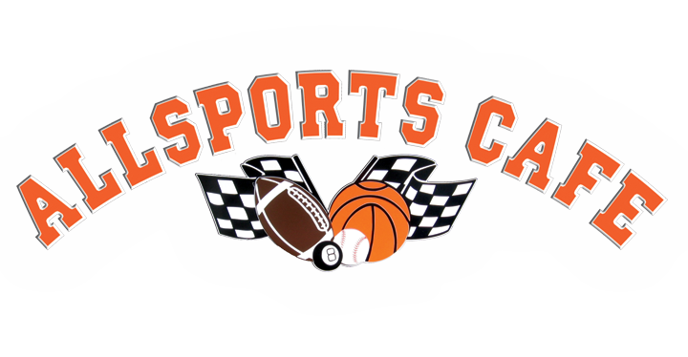
WAIVER OF LIABILITY/PERMISSION/MEDICAL RELEASE FORM

This form is necessary for any contestant of the Allsports Football Kick-off Wing Eating Contest.
You will NOT be allowed to participate without this form completely filled out and signed.

Name of contestant: ___________________________ Date of Birth: ____________

Home address: _______________________________________________________

City __________________________ State ___________________ Zip ________

Phone (_____) ________________________

Email ___________________________________________________________

I hereby release, indemnify and hold harmless The Allsports Football Kick-off Wing Eating Contest , trustees, employees, agents and assigns from any and all liability, damage, claim of any nature whatsoever arising out of or in any way related to my/participating in this contest. Participating in any activity is an acceptance of some risk of injury. I agree that my safety is primarily dependent upon my taking proper care of myself. I assume all risks related to the activities. In case of an emergency, I do hereby authorize and consent to any medical treatment or care deemed advisable.

I have read and agree to comply with the rules and regulations of the Allsports Football Kick-off Wing Eating Contest.

My signature below indicates that I have read, understand and have freely signed this agreement. I expressly agree that this agreement shall be construed and enforced in accordance with Virginia laws and I consent to the jurisdiction of said state. I agree that this waiver and release is intended to be broad and inclusive as permitted by law, so that if any portion hereof is held invalid, the balance shall continue in full legal force and effect.

Contestant Name (print) _____________________________________________

Contestant signature _______________________________________________

Date: _______________________

